SQL Filtering and JOIN Answers

Create Database and Customers Table
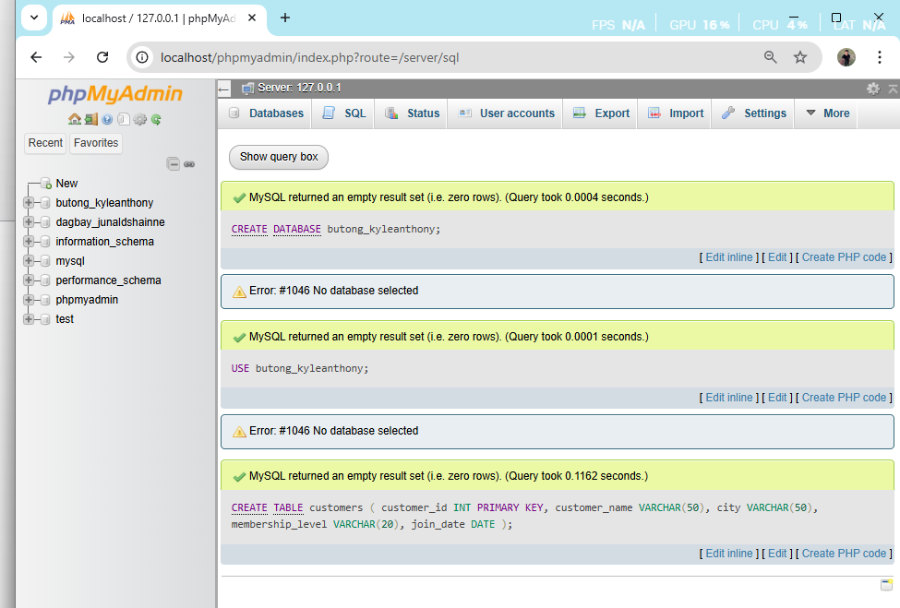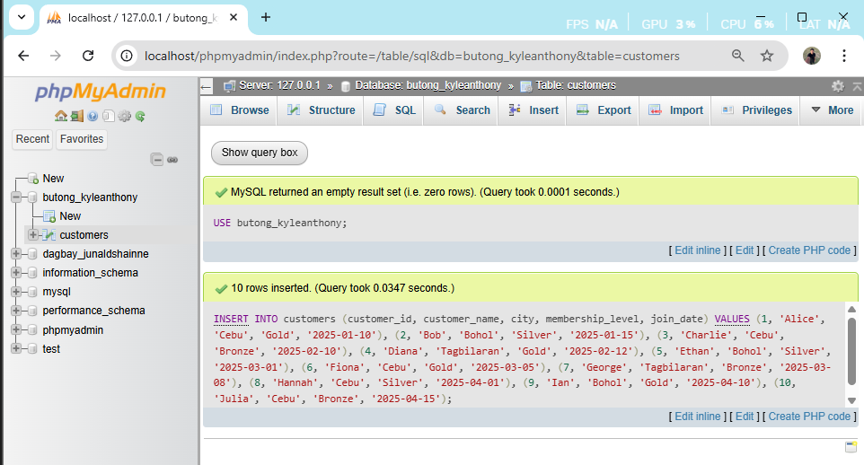

SQL Filtering Activity

1. List all customers from Cebu
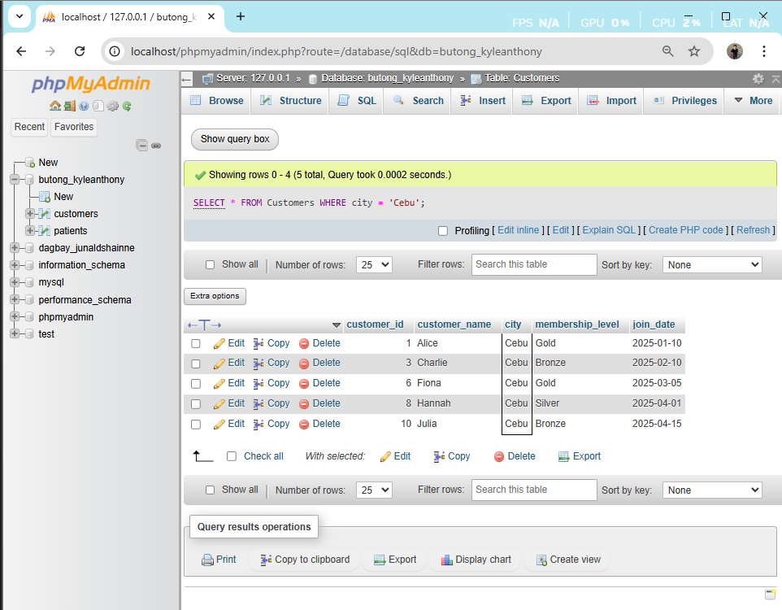

2. Find all Gold membership customers
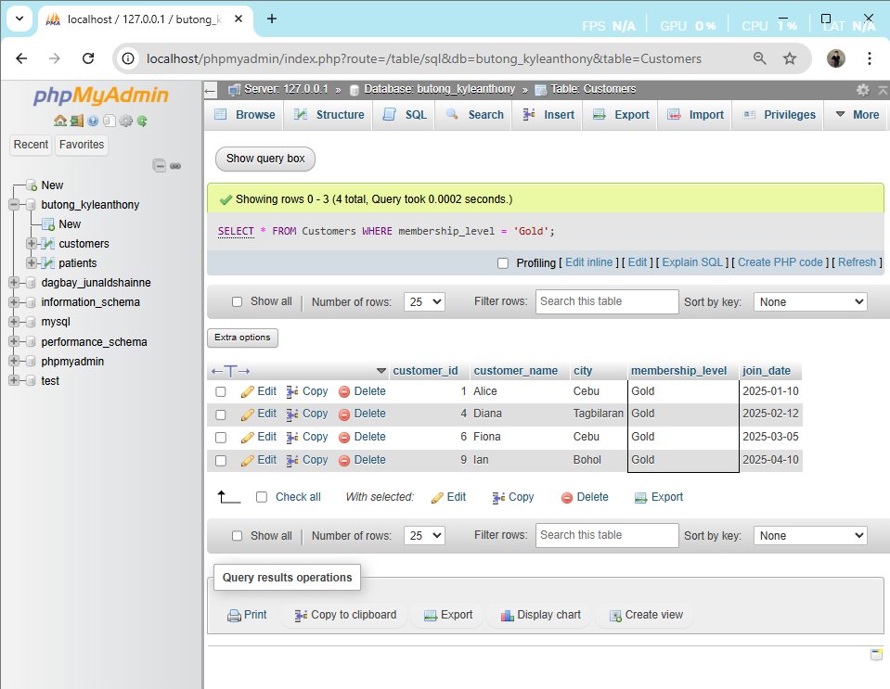

3. List customers whose names start with “A” or “D”.
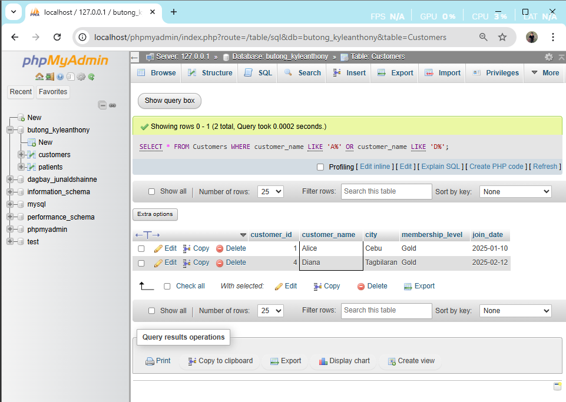

4. Find customers from Cebu who have silver or gold membership.
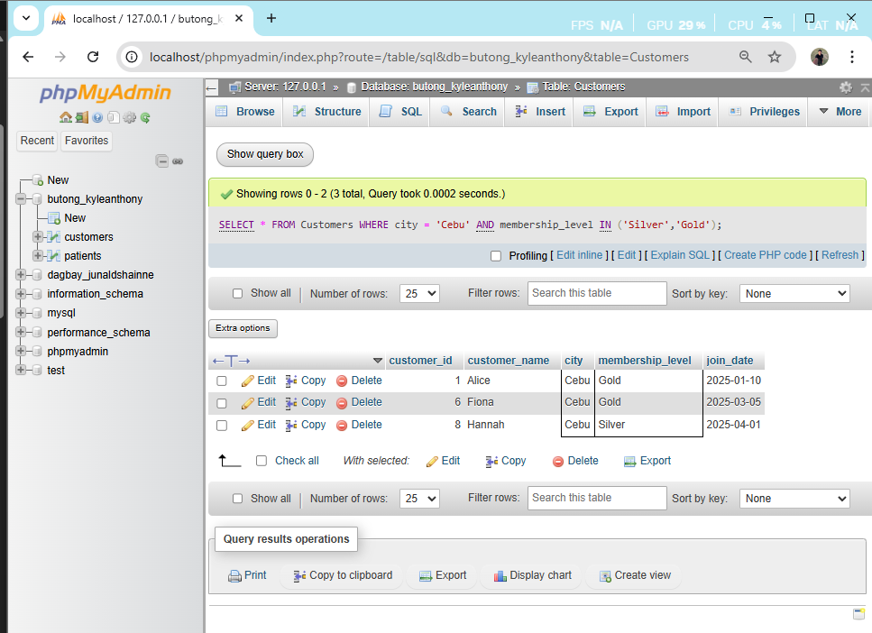

5. Select customers who joined between 2025-02-01 and 2025-03-31.
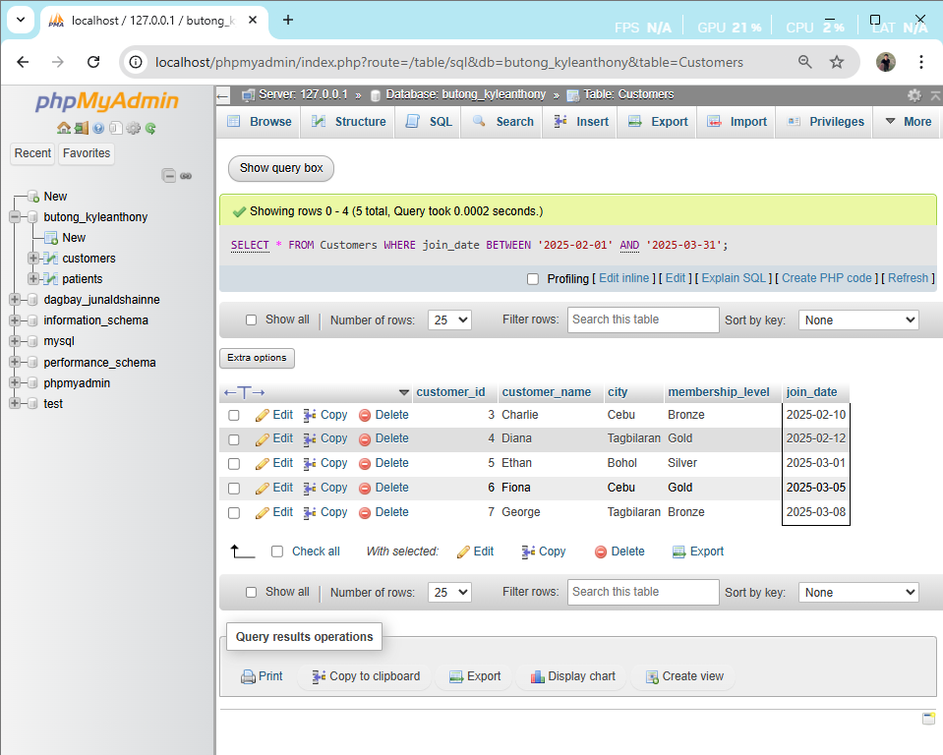

6. Find customers from either Bohol or Tagbilaran with Bronze membership.
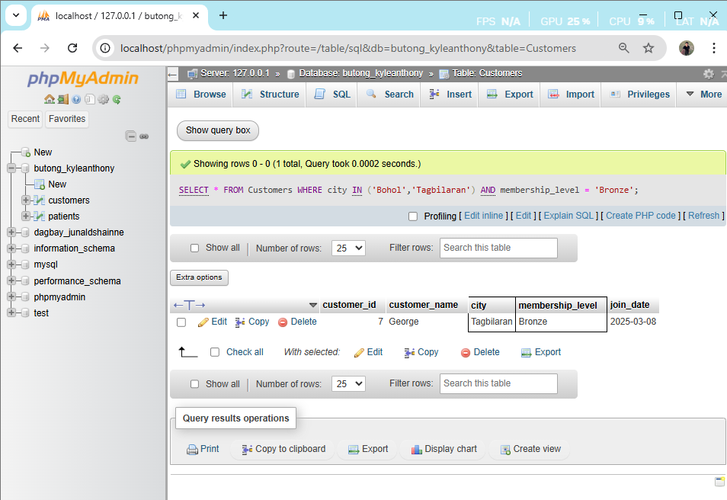

7. List all customers whose names contain the letter “a” (case-insensitive).
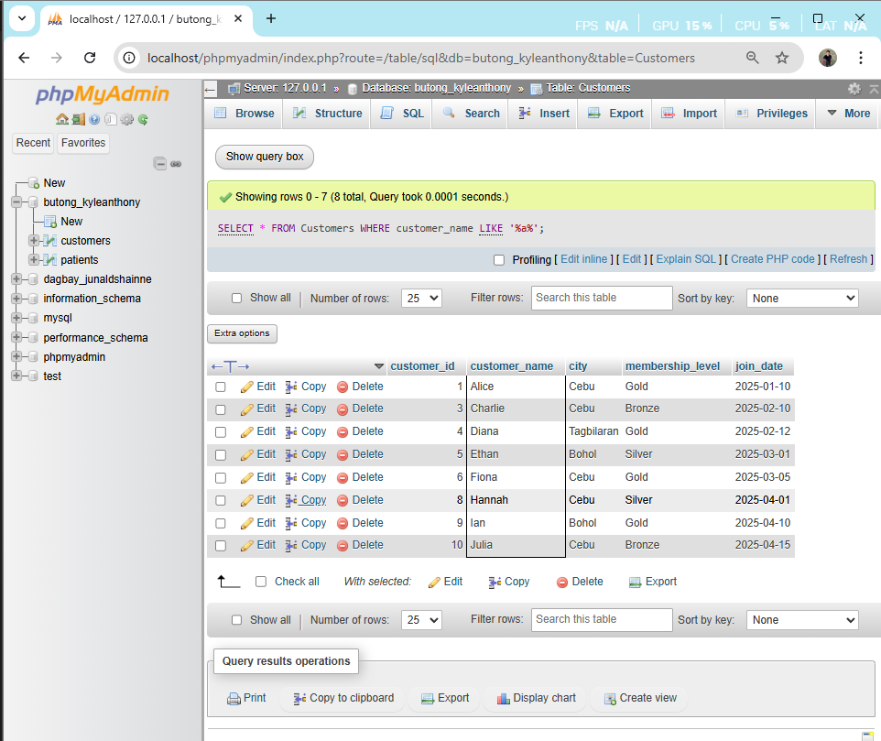

8. Find all customers from Cebu who are gold members and joined before March 2025.
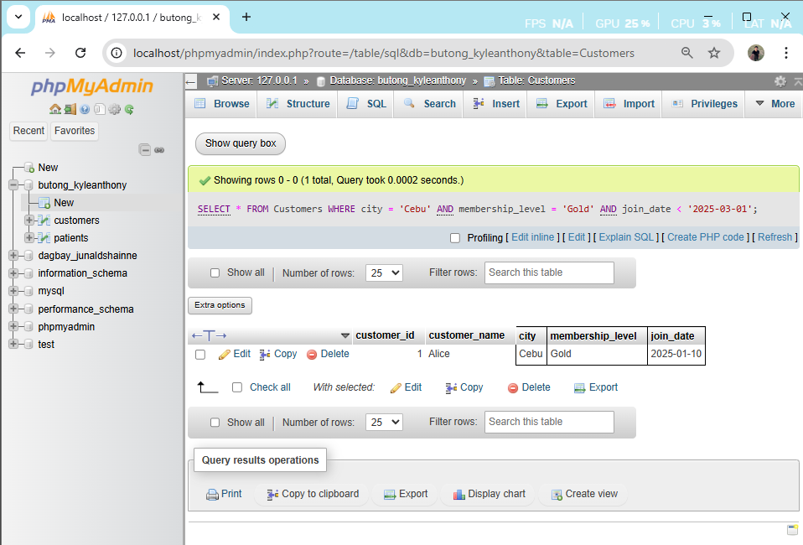

9. List all customers from Bohol or Tagbilaran who joined on or before February 2025 and have silver or bronze membership.
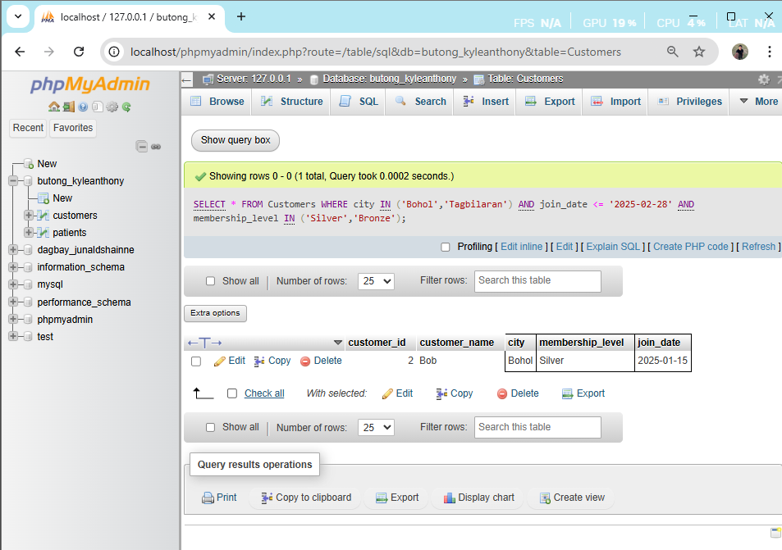

10. Select all customers except those whose customer_id is 1, 4, or 6, and who joined after February 2025.
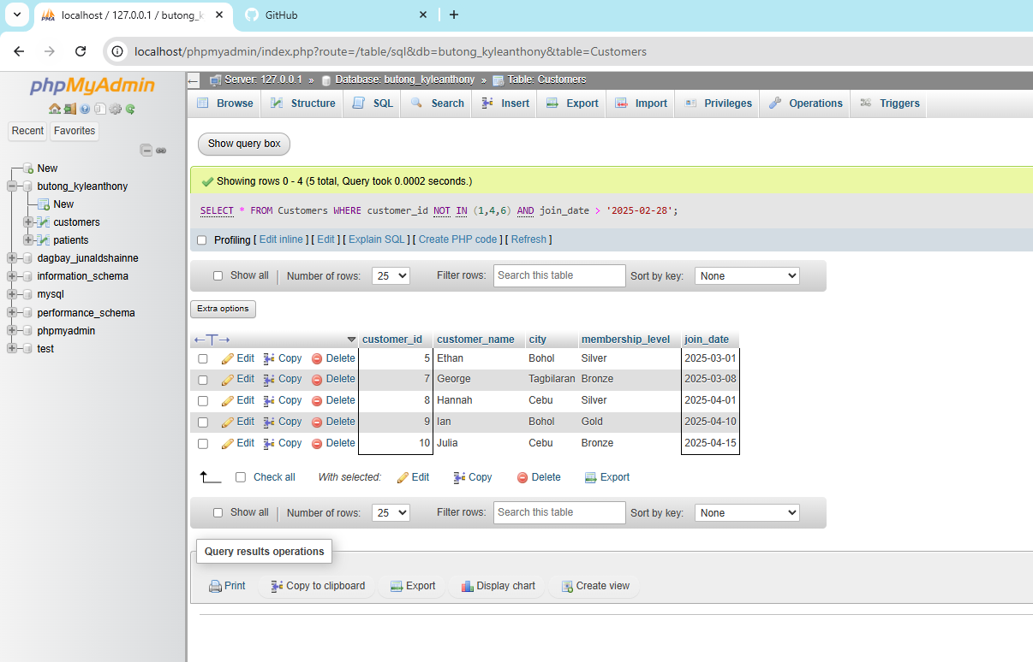

SQL JOIN Operations Activity

Patients Table
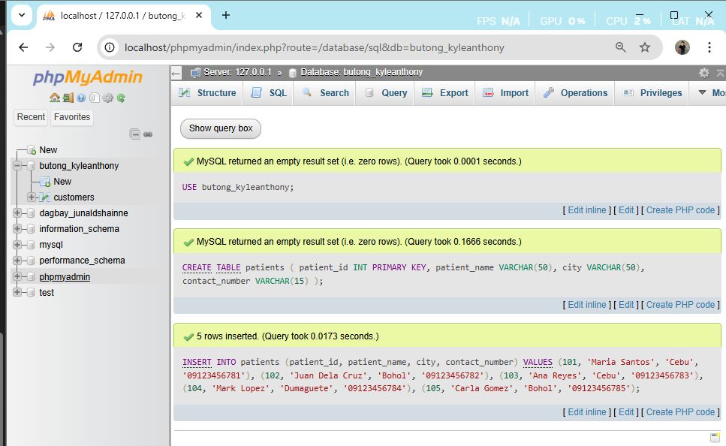
Appointments Table
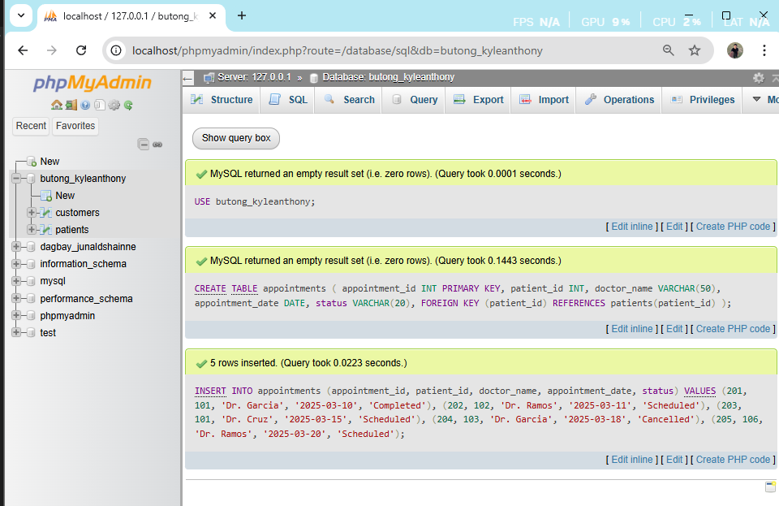

Part A – Basic Join
1. Display the patient’s name and doctor name for all appointments.
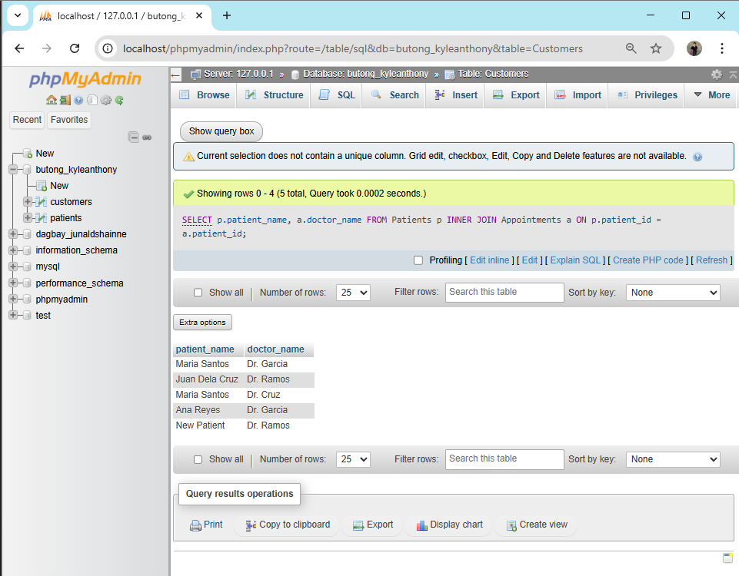
Part B – Filtering with Join
2. Display all patients from Cebu and their appointments.
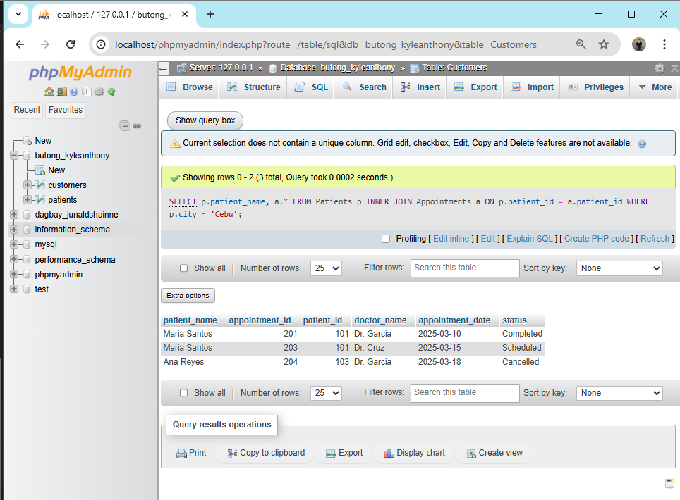

3. Display appointments handled by Dr. Garcia with the patient names.
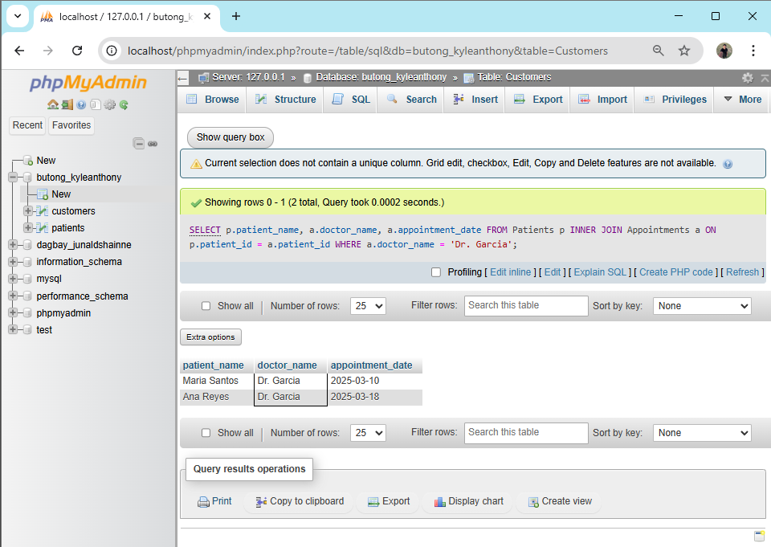
Part C – Analytical Queries
4. Show all patients and their appointments, including patients who do not have appointments.
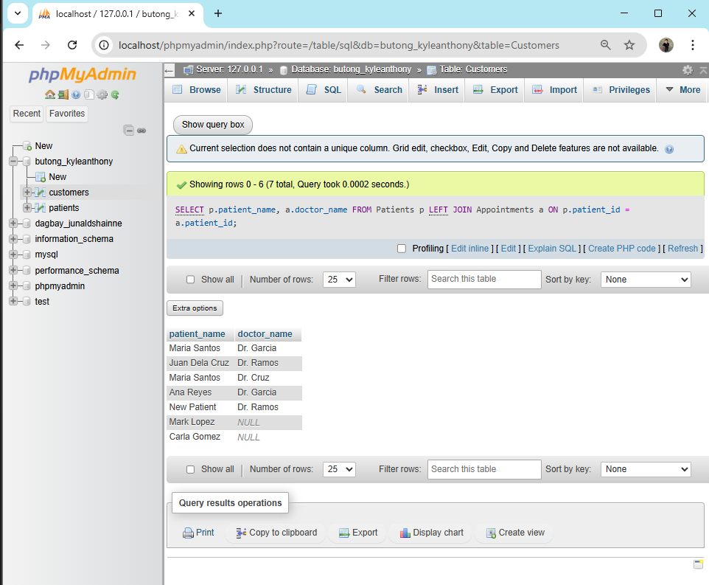

5. Show all appointments even if the patient information does not exist in the Patients table.
